IBF LIST
of designated risk areas, with applicable benefits (as of 1st March 2022):

- IBF Warlike Operations Area – 12 nm. off the mainland Yemeni Coast, including all ports, excluding Maritime Security Transit Corridor (MSTC) in the Red Sea - Charts 1 and 2a
  - bonus equal to basic wage, payable for 5 days minimum + per day if longer;
  - doubled compensations for death and disability;
  - right to refuse sailing, with repatriation at company’s cost and compensation equal to 2 month’s basic wage
  - recommended to operate at ISPS Level 3

- “IBF High Risk Area” – Gulf of Aden + 12 nm. off Somali East Coast
(Shown in red shade on Chart 2 below, excluding the Internationally Recognized Transit
Corridor (IRTC) as detailed in Chart 2a)
- bonus equal to basic wage, payable for the actual duration of stay / transit;
- doubled compensations for death and disability;
- right to refuse sailing, with repatriation at company’s cost
- increased BMP level

- “IBF Extended Risk Zone” – West Indian Ocean and the Red Sea, up to the Yemen/Saudi Arabia border at 16⁰ 22’N (shown on chart 2a and 2b) and including the MSTC (shown on charts 1 and 3) but excluding the Warlike Operations Areas and the High Risk Area designated in 1, and 2a above.
- bonus equal to basic wage, payable only on the day the vessel is attacked;
- doubled compensations for death and disability if occur on the day the vessel is attacked
- increased BMP level

4) “IBF High Risk Area” – Gulf of Guinea: territorial waters (12 n m.), ports and inland waterways of Nigeria and Benin (chart 4a), excluding the MEZ, SAA and the STS* (Shown in green shade on chart 4b below, excluding the Maritime Exclusion Zone (MEZ), the Secure Anchorage Area (SAA) and the Ship-to-Ship Zone (STS) which are to be treated as IBF Extended Risk Zones with identical treatment as Designation 3 above)
- bonus equal to basic wage, payable for the actual duration of stay / transit;
- doubled compensations for death and disability;
- right to refuse sailing, with repatriation at company’s cost (by submitting respective notice)
- increased security requirements

5). “IBF Extended Risk Zone” – Gulf of Guinea, from the Liberia/Ivory Coast border to the Congo/Angola border (chart 5), excluding the IBF High Risk Area specified as Designation 4.
- bonus equal to basic wage, payable only on the day the vessel is attacked;
- doubled compensations for death and disability if occur on the day the vessel is attacked
- increased BMP level

6. IBF Warlike Operations Area – Sea of Azov, north of latitude 46°N (chart 6)
- bonus equal to basic wage, payable for 5 days minimum + per day if longer;
- doubled compensations for death and disability;
- right to refuse sailing, with repatriation at company’s cost and compensation equal to 2 month’s basic wage
- recommended to operate at ISPS Level 3

7. IBF Warlike Operations Area – Northern Black Sea Region (chart 7)
- bonus equal to basic wage, payable for 5 days minimum + per day if longer;
- doubled compensations for death and disability;
- right to refuse sailing, with repatriation at company’s cost and compensation equal to 2 month’s basic wage
- recommended to operate at ISPS Level 3

8. Warlike Operations Area – all ports in Ukraine
- bonus equal to basic wage, payable for 5 days minimum + per day if longer;
- doubled compensations for death and disability;
- right to refuse sailing, with repatriation at company’s cost and compensation equal to 2 month’s basic wage
- recommended to operate at ISPS Level 3

___________________________________________________

* Please see the Attachment for exact coordinates and details.
Notes:
  - In Area 3 above, bonuses and compensations are not payable when the vessel is anchored or berthed in secure ports, except in Somalia and Yemen
  - In Area 4 above, secure berthing in guarded port areas is excluded.

Chart 1: Warlike Area 12nm off the Yemeni Mainland coast (west)

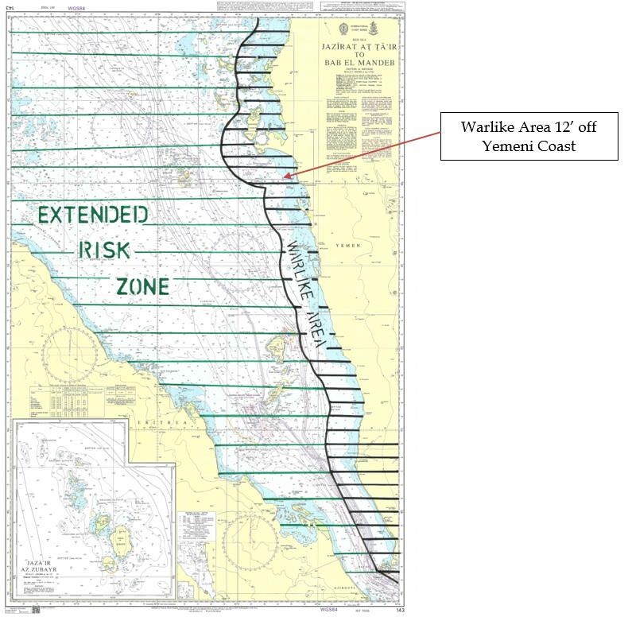

Chart 2a: East Africa

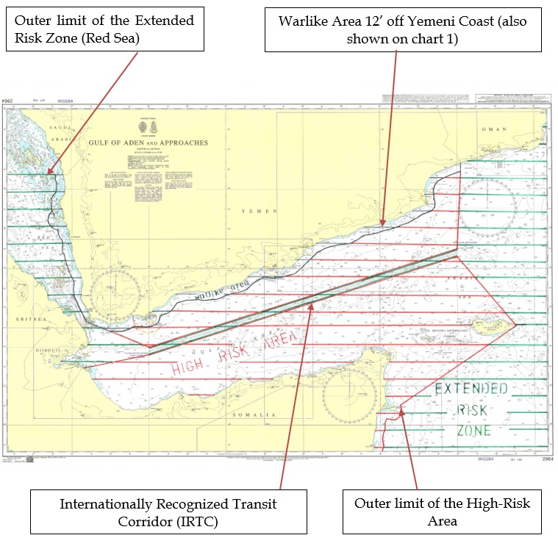

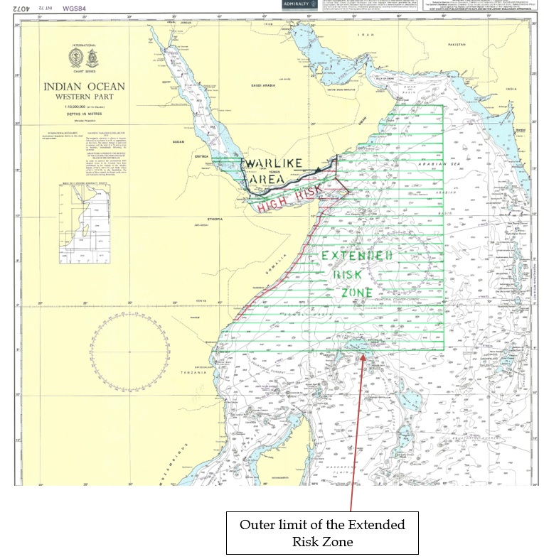
Chart 2b: Indian Ocean

Chart 3: Maritime Security Transit Corridor (MSTC) in the Red Sea and the Bab al-Mandeb Straits

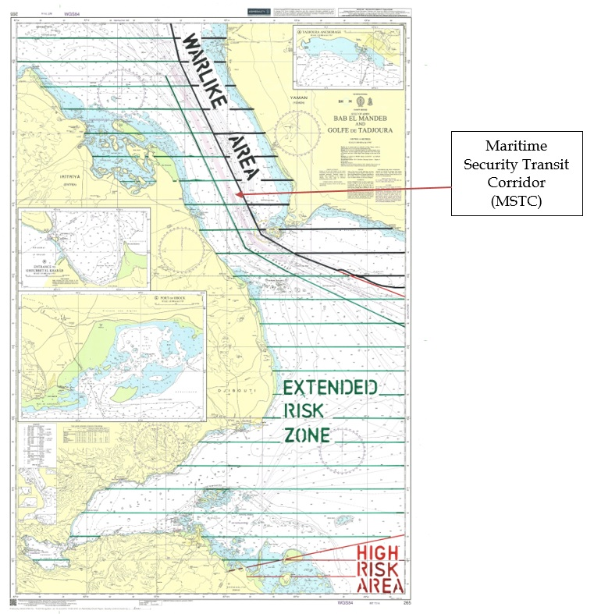

(Vessels transiting within the MSTC are in Extended Risk Zone, NOT Warlike Area or High-Risk Area)

Chart 4a: West Africa – Benin and Nigeria
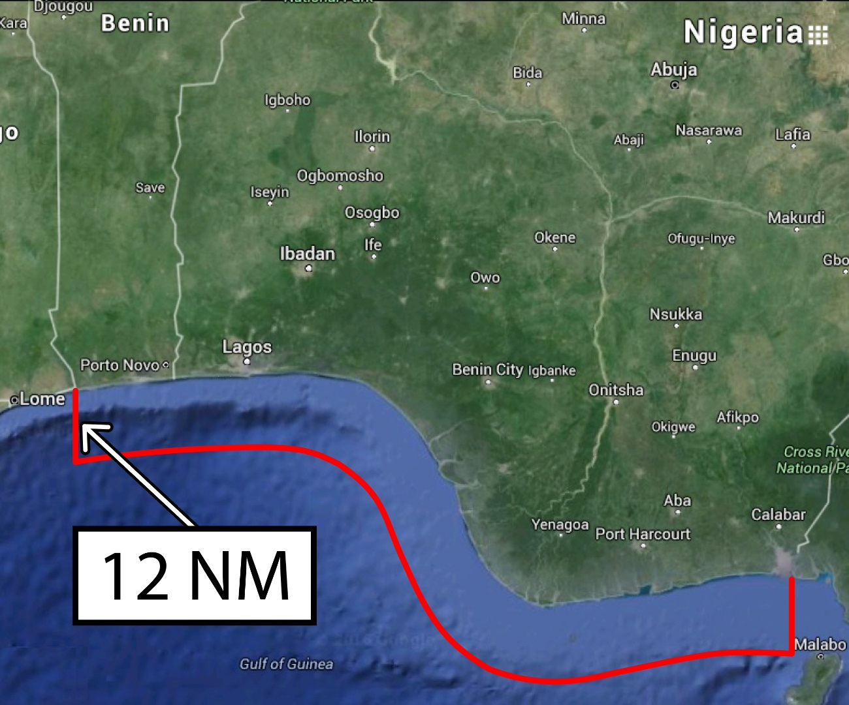

High-Risk Area, 12’ off the coast of Benin and Nigeria

Chart 4b: West Africa (Nigeria) - MEZ, SAA, STS

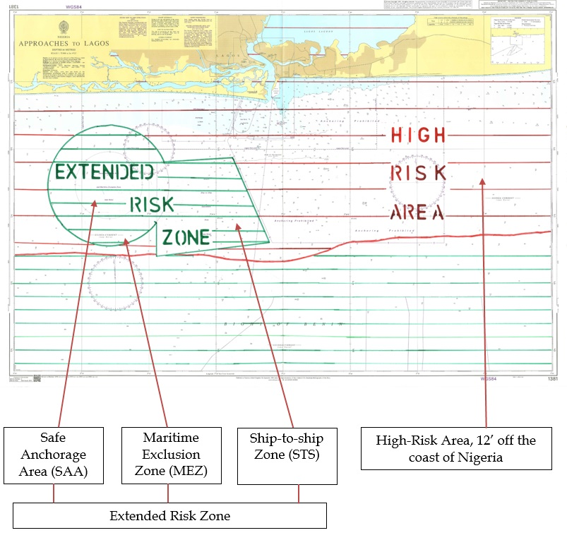

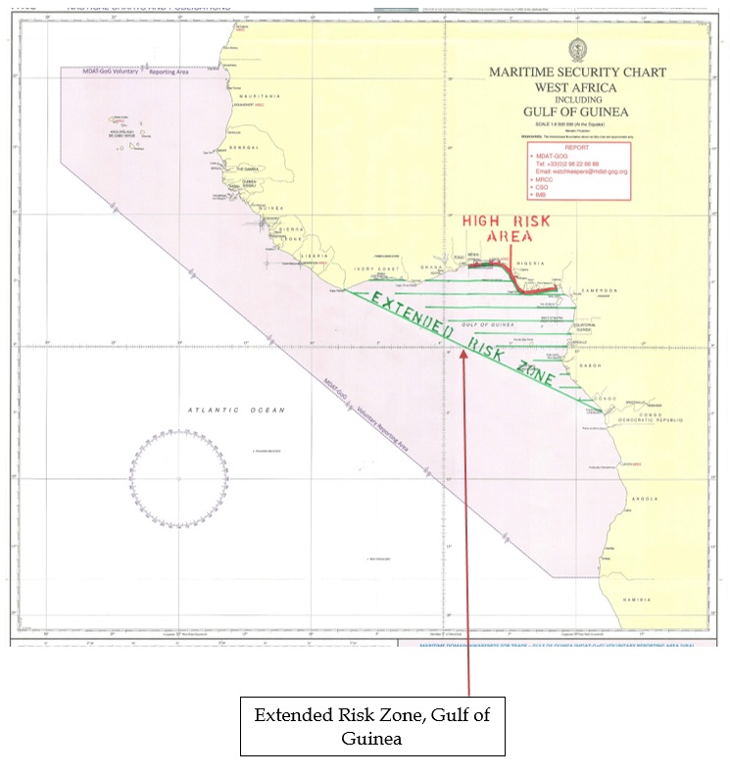
Chart 5: Gulf of Guinea ERZ

Chart 6: IBF Warlike Operations Area – Sea of Azov, north of latitude 46°N
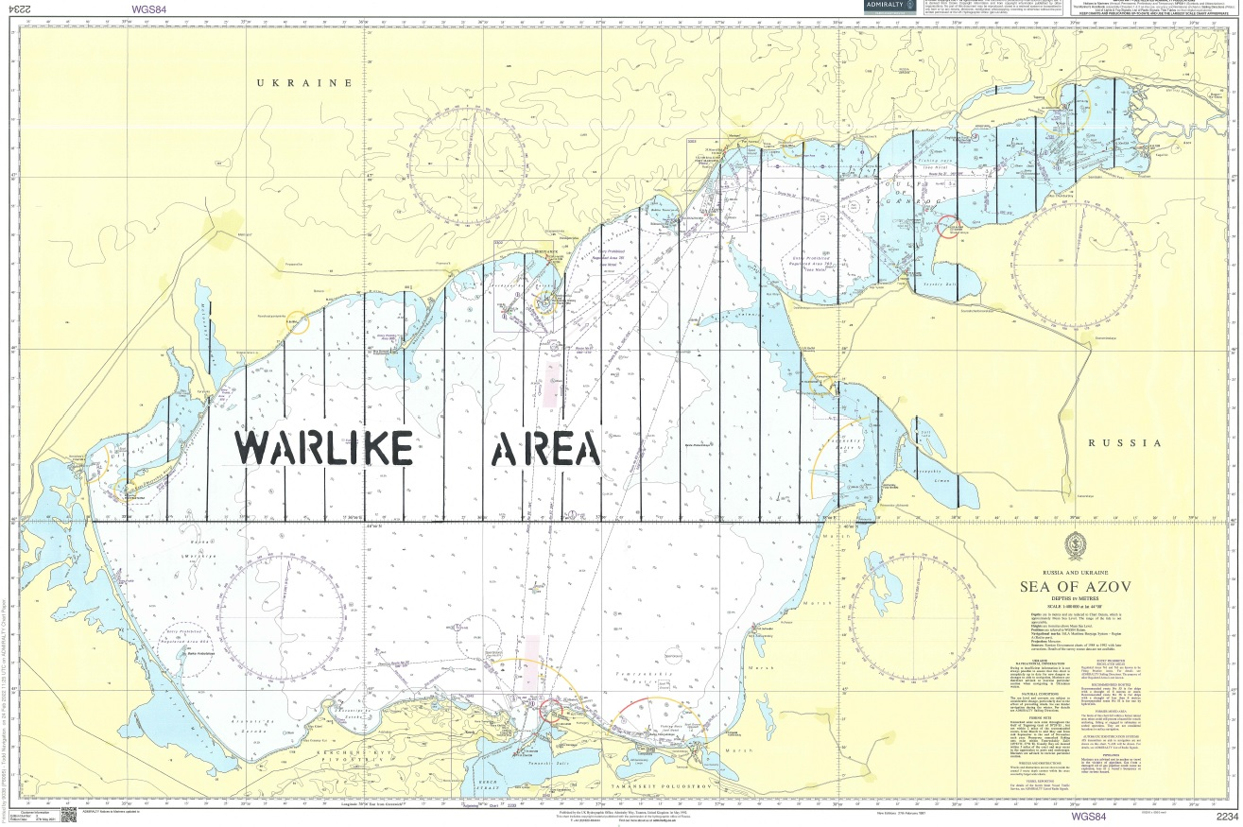

Chart 7: IBF Warlike Operations Area – Northern Black Sea Region
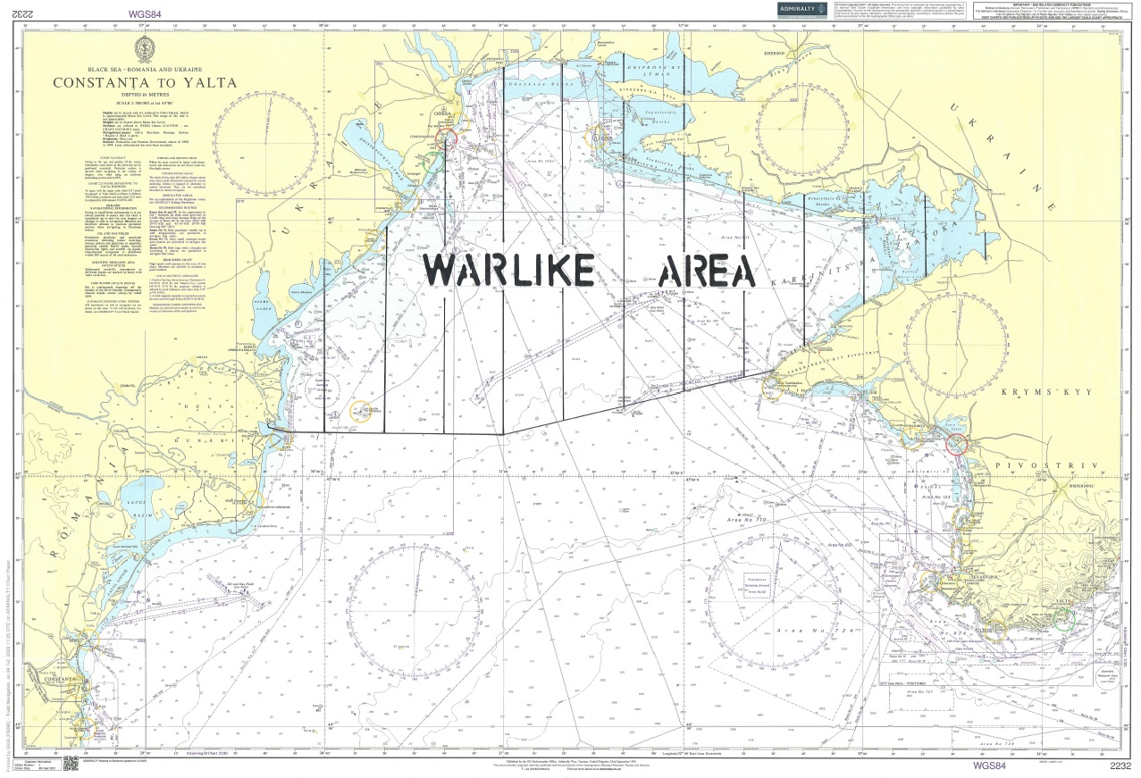

Attachment to the IBF list of warlike and high-risk designations

The details of the areas included in the List are as follows:

DESIGNATION 1.
IBF Warlike Operations Area – 12 n.m. off Yemeni mainland Coast

  - This Warlike Operations Area includes Yemeni territorial waters extending up to the 12 nautical miles limit from the border of Yemen with Saudi Arabia in the Red Sea and the border of Yemen and Oman in the Gulf of Aden, with the exception of the Maritime Security Transit Corridor (MSTC) in the Red Sea where the lanes of these safe passage corridor overlap with this Warlike Area.
  - This Warlike Area applies to all vessels, whether underway or not, including all vessels at anchor and berthed “all fast” within the Area

During a vessel’s transit of this Area, the protection of seafarers through the ISPS Level 3 measure should be adopteds, which may include the provision of personnel or systems which appropriately reduce the vulnerability of a vessel. The sufficiency of such extra security measures should be determined depending on vessel type, size, freeboard during transit and speed, with consulting and seeking advice of respective ITF union(s) where necessary.

During the period of transit/stay within this Warlike Area, seafarers shall be entitled to compensation amounting to 100% of the basic wage and a doubled compensation payable in case of death and disability. This entitlement should be payable for a minimum of 5 days upon the entry into the Area and further for each day of the vessel’s actual stay in the Area.

In the case of vessels transiting the IBF Warlike Area, seafarers have the right not to proceed with the passage. In such an event, the seafarer concerned shall be repatriated at the company’s cost with benefits accrued until date of return to the port of engagement and with the payment of 2 months’ basic wage as compensation.

This Area excludes the Maritime Security Transit Corridor (MSTC) in the Red Sea established by Combined Maritime Forces (CMF). This corridor is patrolled by international naval forces and therefore recommended for a safe passage. Under this IBF List the MSTC is designated as an Extended Risk Zone (Designation 3).

This designation is in force from 0001Z on 1 March 2018.

DESIGNATION 2.
“IBF High Risk Area”: Gulf of Aden + 12 n.m. off Somali East Coast, excluding the IRTC.
  - The Western Border of this High Risk Area runs from the coastline at the border of Djibouti and Somalia to position 11 48 N, 45 E; from 12 00 N, 45 E to Mayyun Island in the Bab El Mandeb Straits. The Eastern Border runs from Rhiy di-Irisal on Suqutra Island to position 14 18 N, 53 E; from 14 30 N, 53 E to the coastline at the border between Yemen and Oman. The Southern Border runs from Rhiy di-Irisal on Suqutra Island to position 10 32 N, 51 34 E with a 12 mile zone off the eastern coast of Somalia, i.e. from position 10 32 N, 51 34 E down to the Kenyan border in the South.

During a vessel’s transit of this Area protection of seafarers through the provision of increased security measures should be adopted. Such measures must be above the latest Best Management Practice (BMP) level and may include the provision of personnel or systems which appropriately reduce the vulnerability of a vessel. The sufficiency of such extra security measures should be determined depending on vessel type, size, freeboard during transit and speed, with consulting and seeking advice of respective ITF union(s) where necessary.

The adoption of Best Management Practice is required as a minimum standard of protection.

During the period of transit of this High-Risk Area seafarers shall be entitled to compensation amounting to 100% of the basic wage and a doubled compensation payable in case of death and disability. This entitlement should apply on each day of the vessel’s stay in the High-Risk Area.

In the case of vessels that will transit the IBF High Risk Area outside of the east bound and west bound lanes created under the International Recommended Transit Corridor (IRTC), seafarers have the right not to proceed with the passage. In such an event, the seafarer concerned shall be repatriated at the company’s cost with benefits accrued until date of return to the port of engagement.

In order to assist the military efforts to counter piracy in this region, all vessels that are subject to a confirmed attack should report to international navies present in the area or other relevant authority, to assist in the deployment of naval resources to appropriate areas, where piracy attacks are occurring.

This designation is in force from 0001Z on 1st July 2014, revised on the 1st November 2020.

DESIGNATION 3.
“IBF Extended Risk Zone” – W. Indian Ocean and Red Sea, with the addition of the Maritime Security Transit Corridor (MSTC) which includes the Internationally Recognized Transit Corridor (IRTC).

The coordinates of this area comprise of and stretch further than the IBF High Risk Area as outlined above.
  - “The Extended Risk Zone runs from Yemen/Saudi Arabia border at 16⁰ 22’N in the Red Sea and 22⁰ N in the Gulf of Oman, to 65⁰ E and 5⁰ S. A Warlike Area or High Risk Area within these coordinates will take precedence, except for transit within the MSTC, which includes the IRTC”.

During a vessel’s transit of this area, protection of seafarers through the provision of increased security measures should be adopted. Such measures must be above the latest Best Management Practice (BMP) level and may include the provision of personnel or systems which appropriately reduce the vulnerability of a vessel. The sufficiency of such extra security measures should be determined depending on vessel type, size, freeboard during transit and speed, with consulting and seeking advice of respective ITF union(s) where necessary.

The adoption of Best Management Practice is required as a minimum standard of protection.

During the period of transit of the Extended Risk Zone, outside the area which is designated as High Risk Area, each seafarer shall be entitled to a bonus equal to 100% of the basic wage and a doubled compensation in case of injury or death - on any day during which the vessel he serving on is attacked. The proof of these entitlements shall be subject to a confirmed entry into the ship’s logbook and a report of attack being lodged with recognised international reporting authorities, such as UKMTO. The maximum period when these entitlements may apply shall not exceed the number of days of the vessel’s transit of the IBF Extended Risk Zone outside the area designated as High-Risk Area. For the purpose of this article an attack means any unauthorised and obvious action taken by a third party in a willful attempt to board or damage the vessel or to harm the crew which leads to the activation of the relevant vessel contingency plans including the alerting of the whole crew.

Within all of the IBF Extended Risk Zone, the above identified entitlements to extra basic pay and extra compensation for injury or death will not apply while vessels are alongside a berth, at anchor in secure anchorages off ports or attached to SBM facilities - with exception of Somali and Yemeni waters and ports.

Vessels may deviate from the MSTC lanes without affecting the terms and conditions for the seafarers onboard for collision avoidance purposes only, as long as they are returned to the original lanes, as soon as it is safe and practicable to do so.

In order to assist the military efforts to counter piracy in this region, all vessels that are subject to a confirmed attack should report to international navies present in the area or other relevant authority, to assist in the deployment of naval resources to appropriate areas, where piracy attacks are occurring.

This designation is in force from 0001Z on 16th December 2015, revised on the 1 March 2018, further revised on the 1st November 2020.

DESIGNATION 4.
“IBF High Risk Area” – Gulf of Guinea, excluding the Maritime Exclusion Zone (MEZ), the Secure Anchorage Area (SAA) and the Ship-to-Ship Zone (STS)

This IBF High Risk Area includes:

  - the territorial waters of Benin and Nigeria, including ports, terminals and roads anchorages, the delta of the Niger river, other inland waterways and port facilities, except only when the vessel is attached securely to a berth or SBM facility in a guarded port area. MEZ, SAA and STS are excluded from this High-Risk Area and are considered Extended Risk Zones.

Within this Area the following provisions should apply:

All companies operating vessels or installations in the above Area should have sufficient security arrangements to safeguard their personnel, given the nature of the risk, and should provide adequate protection, advice and compensations to the crews. Specifically, the following requirements should be complied with:

Upon the vessel’s entry into and, further, throughout the entire stay in the Area as specified above, seafarers must be protected by increased security measures that will provide adequate levels of safety and security on board, such as the Best Management Practice.

In the ports of the above listed countries and inland waterways and approaches to these ports, including offshore installations, extra security measures for reducing the vessel’s vulnerability to an unsanctioned approach and boarding should be adopted. Such measures should, inter alia, provide for an enhanced look-out and an emergency alert/action plan securing sufficient safety for the crew and reliable contact with the authorities. The sufficiency of such extra security measures should be determined depending on the vessel’s type, size and freeboard.

Prior to approaching a port, detailed local advice about the security situation should be obtained and arrivals and departures timed to coincide with security patrols operated by respective government forces, if available.

Shore leave should be prohibited unless exceptional circumstances or emergencies may demand otherwise.

Normal crew changes should not be effected in any above listed country unless absolutely essential.

Under normal circumstances the company shall notify the seafarer if the vessel on which he/she is due to serve/is serving is planned to call into the Area at least 30 days prior to the entry. On receipt of this notification, the seafarer may request to exercise his/her right of repatriation at Company expense, with benefits accrued until date of return to final destination. If it proves impossible for a Company to notify a seafarer more than 30 days prior to the entry (for example due to schedule changes), the Company shall make all reasonable endeavors to repatriate the seafarer at the earliest opportunity, at Company expense, with benefits accrued until date of return to final destination.

The company should pay each seafarer agreeing to proceed into the Area a compensation amounting to 100% of the basic wage for each day of the seafarer’s stay in the Area and a doubled compensation in case of death and/or disability.

In the event of an attack regular liaison should be maintained with seafarers' families to advise them of the status of respective crewmembers working in the Area and the security measures being adopted to safeguard and assist them.

Compared to the terms and conditions of the respective IBF Collective Bargaining Agreement, this agreement may lead to more favorable treatment for seafarers serving in the Area, but in no case will it undermine any existing contractual entitlements.

This designation is in force from 16th December 2015

DESIGNATION 5.
“IBF Extended Risk Zone” – Gulf of Guinea, including the Maritime Exclusion Zone (MEZ), the Secure Anchorage Area (SAA) and the Ship-to-Ship Zone (STS), excluding 12nm off the coast of Nigeria and Benin
The coordinates of this area run in a direct line from the Liberia/Ivory Coast border to the Congo/Angola Border
During a vessel’s transit of this area, protection of seafarers through the provision of increased security measures should be adopted. Such measures must be above the latest Best Management Practice (BMP West Africa) level and may include the provision of personnel or systems which appropriately reduce the vulnerability of a vessel. The sufficiency of such extra security measures should be determined depending on vessel type, size, freeboard during transit and speed, with consulting and seeking advice of respective ITF union(s) where necessary.
The adoption of Best Management Practice is required as a minimum standard of protection.
During the period of transit of the Extended Risk Zone, outside the area which is designated as High Risk Area, each seafarer shall be entitled to a bonus equal to 100% of the basic wage and a doubled compensation in case of injury or death - on any day during which the vessel he serving on is attacked. The proof of these entitlements shall be subject to a confirmed entry into the ship’s logbook and a report of attack being lodged with recognised international reporting authorities, such as MDAT-GoG. The maximum period when these entitlements may apply shall not exceed the number of days of the vessel’s transit of the IBF Extended Risk Zone outside the area designated as High-Risk Area. For the purpose of this article an attack means any unauthorised and obvious action taken by a third party in a willful attempt to board or damage the vessel or to harm the crew which leads to the activation of the relevant vessel contingency plans including the alerting of the whole crew.
This designation is in force from 0001Z on 1st November 2020

DESIGNATION 6:
Warlike Operations Area – Sea of Azov, north of latitude 46°N.
During a vessel’s transit of this Area, the protection of seafarers through the ISPS Level 3 measure should be adopteds, which may include the provision of personnel or systems which appropriately reduce the vulnerability of a vessel. The sufficiency of such extra security measures should be determined depending on vessel type, size, freeboard during transit and speed, with consulting and seeking advice of respective ITF union(s) where necessary.

During the period of transit/stay within this Warlike Area, seafarers shall be entitled to compensation amounting to 100% of the basic wage and a doubled compensation payable in case of death and disability. This entitlement should be payable for a minimum of 5 days upon the entry into the Area and further for each day of the vessel’s actual stay in the Area.

In the case of vessels transiting the IBF Warlike Area, seafarers have the right not to proceed with the passage. In such an event, the seafarer concerned shall be repatriated at the company’s cost with benefits accrued until date of return to the port of engagement and with the payment of 2 months’ basic wage as compensation.

The designation is in effect from 1st March 2022 until 15th March 2022, unless extended by mutual consent

DESIGNATION 7:
Warlike Operations Area - Northern Black Sea Region
  - This Warlike Operations Area runs from the Ukrainian/Romanian border to position 45° 10’N 031° 00’E and to position 45° 25’N 032° 30’E.
The entitlements are the same as those listed in Designation 6 above (IBF WOA Sea of Azov, north of latitude 46°N)

The designation is in effect from 1st March 2022 until 15th March 2022, unless extended by mutual consent

DESIGNATION 8:
Warlike Operations Area – all ports in Ukraine

- This Warlike Area applies to all vessels, whether underway or not, including all vessels at anchor and berthed “all fast” within the Area
The entitlements are the same as those listed in Designation 6 above (IBF WOA Sea of Azov, north of latitude 46°N)

The designation is in effect from 1st March 2022 until 15th March 2022, unless extended by mutual consent

